**ZC-ITX6412 Fanless Thin Mini Itx Motherboard Onboard Intel Elkhart Lake J6412 CPU,1*HDMI,1*VGA,1*LVDS,**

**1 or 2*RJ45,2*USB 3.0,6*USB 2.0,4*RS232+2*RS485/232**

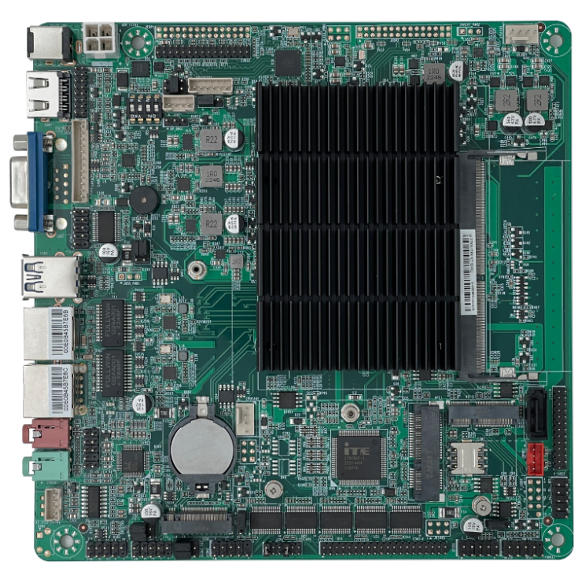

**Main Features**

1.) Onboard Intel Elkhart Lake J6412

2.) Support 3 display VGA,HDMI, LVDS

3.) With 1 or 2 Realtek RTL8111H Gigabit

4.) 6 COM Ports,4*RS232+2*RS232/485

5.) 1*SATA+1*M.2 for SATA/NVEM SSD

6.) 1*mPCIE +M.2 Slot for WIFI/BL

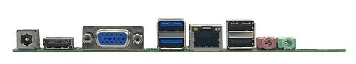

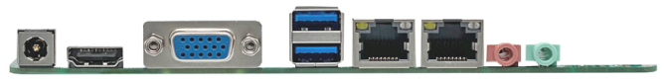

**ZC-ITX6412 Fanless Mini Itx Motherboard onboard J6412 CPU**

|  |  |
| --- | --- |
| **Processor** | Intel Elkhart Lake J6412,4 Cores 2.0GHz Burst to 2.6GHz,TDP 10W |
| **Memory** | 1*SO-DIMM DDR4 Slot,Max 16GB |
| **Display** | Intel UHD Graphics for 10th Gen Intel Processors |
| 1*VGA+ 1*HDMI+1*LVDS,EDP Optional,Support 3 Display |
| **Network** | 1 or 2 Realtek RTL8111H Gigabit LAN,support Wake-on-LAN/PXE |
| **Storage** | 1*7pin SATA3.0,6Gbps |
| 1*M.2 Key M Support NVME/SATA SSD |
| **Audio** | Onboard ALC897 7.1 6-channel high-fidelity audio controller |
| Support MIC/Line-out, power amplifier-2 ohm 5W dual channel |
| **Expansion Slot** | 1*mPCIE |
| 1*M.2 Key E Support WIFI/BL |
| **Rear I/O Port** | 1*12V DC Port |
| 1*HDMI |
| 1*VGA |
| 1*RJ45 (LAN2 either-or 2*USB 2.0) |
| 1*Line out (green), 1*MIC(red) |
| 2*USB3.0 |
| 2*USB 2.0 (LAN2 either-or 2*USB 2.0) |
| **Inside I/O Ports** | 1*JHDMI,2*8Pin (optional) |
| 1*JVGA,1*12Pin (same signal as DB15) |
| 1*LVDS,2*15pin,Dual channel 24bit (either-or eDP) |
| 1*Screen backlight power supply,1*6pin |
| 1*eDP,2*15pin (choose one from LVDS, optional) |
| 4 ore 6*USB 2.0,2*5Pin  (1 LAN Version Support 4 USB 2.0,2 LAN Version support 6*USB 2.0) |
| 1*Front audio,2*5pin |
| 1*Amplifier,1*4pin |
| 1*LPT |
| 1*4pin ATX power |
| 1*SATA Power |
| 1* Front panel switch button and indicator,2*5Pin |
| 6*COM (COM1-2 support RS485, COM1/2 9P is powered, optional support 4*485) |
| **Fan** | Fanless cooling design, reserved 1*4pin CPU fan,1*4pin system fan |
| **GPIO** | Support 4 input and output GPIO |
| **BIOS** | 128Mb Flash ROM |
| **Watchdog** | Support hardware reset function (256 levels, 0~255 seconds) |
| **Operating System** | Windows 10/11/Linux |
| **Power Type** | DC 12V |
| **Operating Temp** | -20℃ to +60℃ |
| **Storage Temp** | -20℃to +70℃ |
| **Working Humidity** | 5%-95% relative humidity, no condensation |
| **Size** | 170mm x 170mm |

**Ordering：**

|  |  |  |  |  |  |  |  |  |  |  |  |  |  |  |
| --- | --- | --- | --- | --- | --- | --- | --- | --- | --- | --- | --- | --- | --- | --- |
| **#** | **Model #** | **CPU** | **Core** | **GHZ** | **RAM** | **HDMI** | **VGA** | **LVDS** | **EDP** | **LAN** | **USB** | **LPT** | **COM/485** | **POWER** |
| 1 | ZC-ITX6412-L1C2 VER1.0 | J6412 | 4 | 2.0G | DDR4 | 1 | 1 | 1 | / | 1 | 8 | 1 | 2 / 1 | 12V |
| 2 | ZC-ITX6412-L1C6 VER1.0 | J6412 | 4 | 2.0G | DDR4 | 1 | 1 | 1 | / | 1 | 8 | 1 | 6 / 2 | 12V |
| 3 | ZC-ITX6412-L2C6 VER1.0 | J6412 | 4 | 2.0G | DDR4 | 1 | 1 | 1 | / | 2 | 8 | 1 | 6 / 2 | 12V |